EXPERIMENT ASSESSMENT
ACADEMIC YEAR 2025-26

Course: Multidisciplinary Minor
Course code: MDC401
Year: SE SEM: IV
Experiment No. 8
AIM: Use XSLT (eXtensible Stylesheet Language Transformations) to convert XML data into an HTML table for better presentation.Create an XML file (books.xml) containing book details (Title, Author, Price). Write an XSL file (books.xsl) that transforms the XML data into an HTML table. Link the XSL with XML and open it in a browser to see the formatted output.
Name: Ashish Ramesh Patel
Roll Number: 55
Date of Performance:
Date of Submission:

Evaluation
Performance Indicator | Max. Marks | Marks Obtained
Performance | 5
Understanding | 5
Journal work and timely submission. | 10
Total | 20

Performance Indicator | Exceed Expectations  (EE) | Meet Expectations  (ME) | Below Expectations  (BE)
Performance | 5 | 3 | 2
Understanding | 5 | 3 | 2
Journal work and  timely submission. | 10 | 8 | 4

Checked by

Name of Faculty: Dr. Yogesh Pingle

Aim: Use XSLT (eXtensible Stylesheet Language Transformations) to convert XML data into an HTML table for better presentation.Create an XML file (books.xml) containing book details (Title, Author, Price). Write an XSL file (books.xsl) that transforms the XML data into an HTML table. Link the XSL with XML and open it in a browser to see the formatted output.

Theory:
React is a popular JavaScript library used for building interactive user interfaces. Traditionally, React applications used class components to manage state and lifecycle methods. With the introduction of React Hooks, functional components can now manage state and side effects more efficiently.

React Hooks
Hooks are special functions in React that allow developers to “hook into” React features such as state and lifecycle methods from functional components. Hooks improve code readability, reusability, and reduce complexity.

useState Hook
The useState hook is used to manage state in functional components. State refers to data that can change over time and affects what is rendered on the screen.
In a counter application, the counter value is stored as state. Whenever the state changes, React automatically re-renders the component to reflect the updated value.

useEffect Hook
The useEffect hook is used to handle side effects in functional components. Side effects include:
- Updating the document title
- Fetching data
- Logging values
- Running code after component render
In this experiment, useEffect is used to update the browser title whenever the counter value changes, demonstrating how side effects are handled in React.

Component Re-rendering
Whenever the state changes using useState, React re-renders the component. The useEffect hook runs after rendering, ensuring that side effects are synchronized with the component’s state.

Algorithm / Procedure
- Start the experiment.
- Create a new React application using create-react-app.
- Open the project folder in VS Code.
- Create a functional component for the Counter App.
- Initialize counter state using useState.
- Add buttons to increment and decrement the counter value.
- Use useEffect to update the document title when the counter changes.
- Display the counter value dynamically on the webpage.
- Run the React application in the browser.
- Stop the experiment.
Code:
▪ books.xml

<?xml version="1.0" encoding="UTF-8"?>
<?xml-stylesheet type="text/xsl" href="books.xsl"?>
<catalog>
<book>
<title>The Pragmatic Programmer</title>
<author>Andy Hunt, Dave Thomas</author>
<price>45.00</price>
</book>
<book>
<title>Clean Code</title>
<author>Robert C. Martin</author>
<price>38.50</price>
</book>
<book>
<title>Design Patterns</title>
<author>Erich Gamma, Richard Helm</author>
<price>55.99</price>
</book>
<book>
<title>JavaScript: The Good Parts</title>
<author>Douglas Crockford</author>
<price>29.99</price>
</book>
</catalog>

▪ books.xsl

<?xml version="1.0" encoding="UTF-8"?>
<xsl:stylesheet version="1.0" xmlns:xsl="http://www.w3.org/1999/XSL/Transform">

<xsl:template match="/">
<html>
<head>
<title>Book Catalog</title>
<style>
body { font-family: Arial, sans-serif; background-color: #f9f9f9; padding: 20px; }
h2 { text-align: center; color: #333; }
table { border-collapse: collapse; width: 60%; margin: 0 auto; background-color: white; box-shadow: 0 2px 5px rgba(0,0,0,0.1); }
th, td { border: 1px solid #ddd; padding: 12px; text-align: left; }
th { background-color: #007bff; color: white; }
tr:nth-child(even) { background-color: #f2f2f2; }
tr:hover { background-color: #ddd; }
</style>
</head>
<body>
<h2>Available Books</h2>
<table>
<tr>
<th>Title</th>
<th>Author</th>
<th>Price (₹)</th>
</tr>

<xsl:for-each select="catalog/book">
<tr>
<td><xsl:value-of select="title"/></td>
<td><xsl:value-of select="author"/></td>
<td>₹<xsl:value-of select="price"/></td>
</tr>
</xsl:for-each>

</table>
</body>
</html>
</xsl:template>
</xsl:stylesheet>

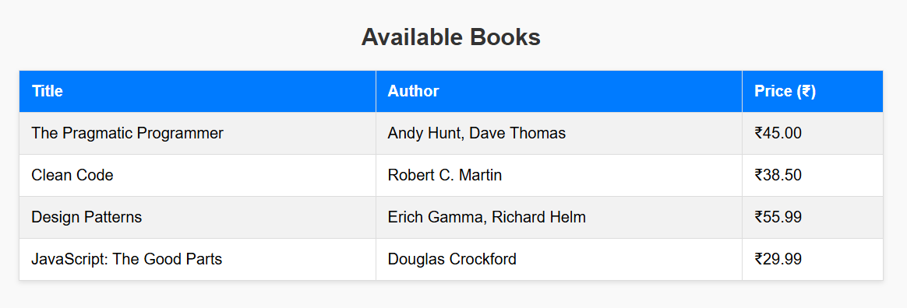
Output:

Conclusion
Thus, a simple counter application was successfully developed using React Hooks. The experiment demonstrates the use of useState for state management and useEffect for handling side effects. This approach simplifies component logic and improves code readability in modern React applications.
Questions:
1.What are React Hooks?
Ans:
Definition: React Hooks are special functions that let you use state and lifecycle features in functional components.
Key Points:
- Introduced in React 16.8.
- Common hooks: useState, useEffect, useContext.
- Simplify code by avoiding class components.
- Enable reusability of logic across components.

2.How does React re-render components?
Ans:
Definition: React re-renders components when their state or props change.
Key Points:
- Virtual DOM is updated and compared with previous DOM (diffing).
- Only changed parts are re-rendered (efficient updates).
- Hooks like useEffect run after re-render to handle side effects.
- Prevent unnecessary re-renders using React.memo or useCallback.

